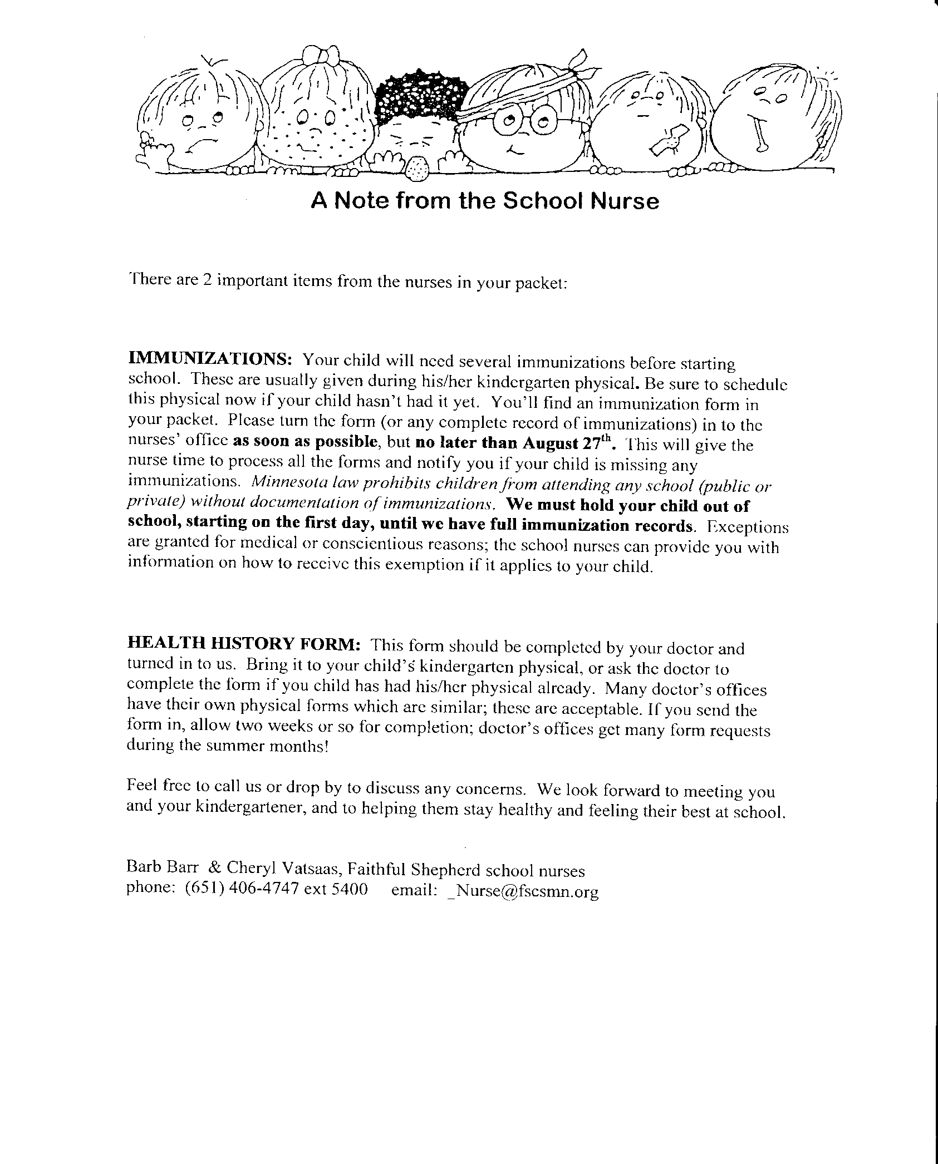

# HEALTH INFORMATION FOR KINDERGARTEN

**IMMUNIZATIONS**: Your child will need several immunizations before starting school. Immunizations are usually given at the pre-kindergarten physical. Be sure to schedule this physical now if your child hasn’t had it yet. You’ll find an immunization form in your packet, as well as a list of required vaccines (“Are Your Kids Ready?”). Please turn in a complete record of immunizations to the nurses’ office as soon as possible, **but no later than the last Monday in August.** This willgive the nurse time to process all the forms and notify you if your child is missing any immunizations. *Minnesota law prohibits children from attending any school (public or private) without documentation of immunizations.* **We must hold your child out of school until we have full immunization records.** Exceptions are granted for medical or conscientious reasons; the school nurses can provide you with information on how to receive this exemption if it applies to your child.

**HEALTH HISTORY FORM:** This form should be completed by your doctor and turned in to us. Bring it to your child’s pre-kindergarten physical, or contact your doctor for completion if your child had their physical already. Many doctor’s offices have their own physical forms which are similar; these are acceptable. If you send the form in, allow two weeks or so for completion; doctor’s offices get many form requests during the summer months!

**HEALTH CONCERNS:** Notify the nurses if your child has any ongoing health concerns (asthma, diabetes, food/other allergies, frequent illnesses,etc). We’ll work together to figure out the best way to handle any health needs at school, and to notify teachers and other appropriate support staff (phy ed, kitchen, etc.).

SICK DAYS: Healthy kids are better learners! Please keep your student home if they have had vomiting or diarrhea within the last 24 hours; a fever (typically, 100.0 degrees or more) within the last 24 hours; or signs of contagious diseases (strep throat, impetigo, ringworm, etc.) until 24 hours after starting medication or until cleared by their health care provider.

**NURSE VISITS:** We are here to help your child if they become ill or injured during the school day. If your child is ill enough to need to go home, we will call you to come pick them up. We will also notify you if your child is seen repeatedly in our office or if we have any concerns about their health. We may send a note home with your child regarding a single office visit that is notable.

A nurse is present every school day from 7:45am-2:45pm. Feel free to call us, email, or drop by at any time to discuss concerns. We look forward to meeting you and your kindergartener, and to helping them stay healthy and feeling their best at school. Thank you!

Cheryl Vatsaas, RN, LSN; and Carolyn Czaplewski, LPN

Faithful Shepherd School Nurses

Phone: 651-262-2889

Email: [fscsnurse@fscsmn.org](mailto:_Nurse@fscsmn.org)

Version 6/2019