8th Grade World Geography 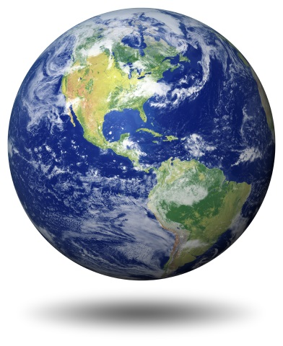
Mr. Brew

Curriculum:
Discovering World Geography: McGraw-Hill Education 2014

Topics Covered: Geography of the World

Course Description: Eight grade World Geography is dedicated to teaching the students about all the continents in the world. Students will be learning about the physical geography, history, people, economy, politics, and cultures of different countries on each continent in the world. Critical thinking skills are emphasized throughout the course as students study World Geography. Students will also work on developing skills in teamwork, note taking, identifying places on a map, and writing essay papers.

Homework: There will be worksheets, activities, and projects. Assignments are always due the next day unless otherwise noted. There will be two to three essay papers on different countries in the world during the school year.

Tests: The test schedule will be posted on the website each week so students can plan ahead. Each test will cover 1 chapter in the text. The tests can consist of matching, multiple choice and some short answer type questions based on the text and class notes.

Grading: 50% Tests
25% Assignments
10% Current Events
15% Projects

Questions: Please feel free to contact me at any time with questions or concerns. I can be reached through e-mail at bbrew@fscsmn.org. I will make every effort to respond within 24 hours.

